LAB PROGRAMS
Day 1- 07/01/2026
Name: K. Guna Shekar Reddy
Register Number: 192424323
Course: CSA0412-Fundamentals of Data Science for Data Analytics

Experiment 1
Program:
import numpy as np
student_scores = np.loadtxt("student_scores.csv",delimiter=",",skiprows=1,usecols=(1, 2, 3, 4)
)
subjects = ["Maths", "Science", "English", "History"]
average_scores = np.mean(student_scores, axis=0)
highest_subject = subjects[np.argmax(average_scores)]
print("Average Scores:", np.round(average_scores, 2))
print("Highest Subject:", highest_subject)
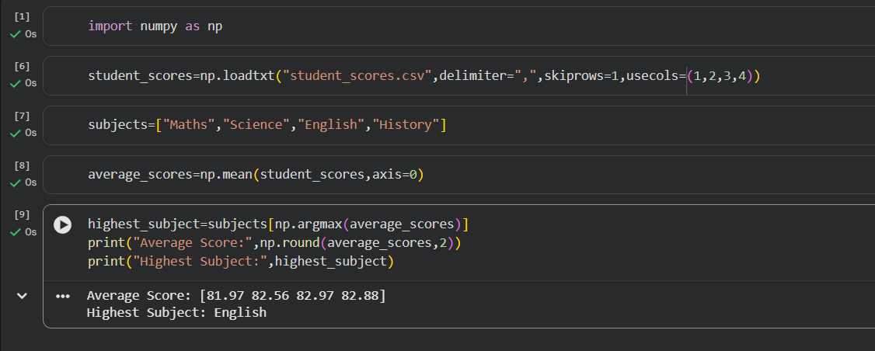
Output:
Experiment 2
Program:
import numpy as np
import pandas as pd
data = pd.read_csv("sales_data.csv")
sales_data = data.select_dtypes(include=[np.number]).to_numpy()
average_price = np.mean(sales_data)
print("Average price of all products sold in the past month:", average_price)

Output:
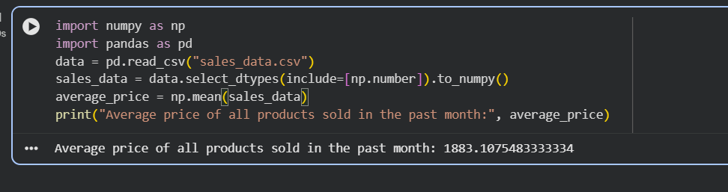

Experiment 3
Program:
import numpy as np
import pandas as pd
data = pd.read_csv("house_data.csv")
house_data = data.to_numpy()
filtered_houses = house_data[house_data[:, 0] > 4]
sale_prices = filtered_houses[:, 2]
average_sale_price = np.mean(sale_prices)
print("Average sale price of houses with more than 4 bedrooms:", average_sale_price)

Output:
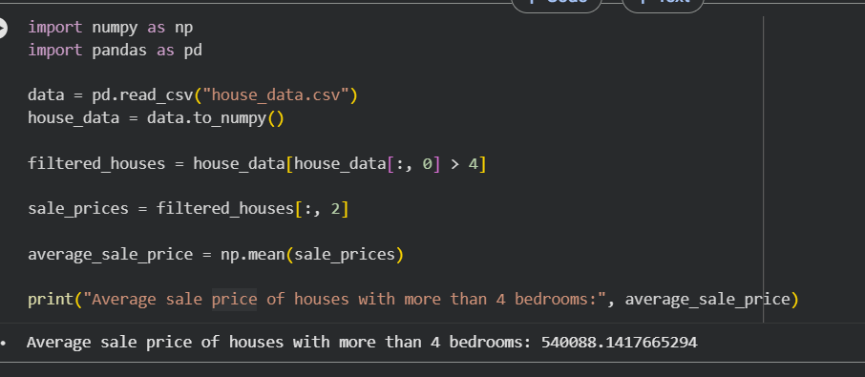

Experiment 4
Program:
import pandas as pd
import numpy as np
df = pd.read_csv("Sales_data.csv")
q1_sales = df[df["Month_sales"].str.contains("January|February|March")]["Total"].sum()
q4_sales = df[df["Month_sales"].str.contains("October|November|December")]["Total"].sum()
sales_data = np.array([q1_sales, q4_sales])
total_sales = np.sum(df["Total"].to_numpy())
percentage_increase = ((sales_data[1] - sales_data[0]) / sales_data[0]) * 100
print("Total sales for the year:", round(total_sales, 2))
print("Percentage increase from Q1 to Q4:", round(percentage_increase, 2), "%")

Output:
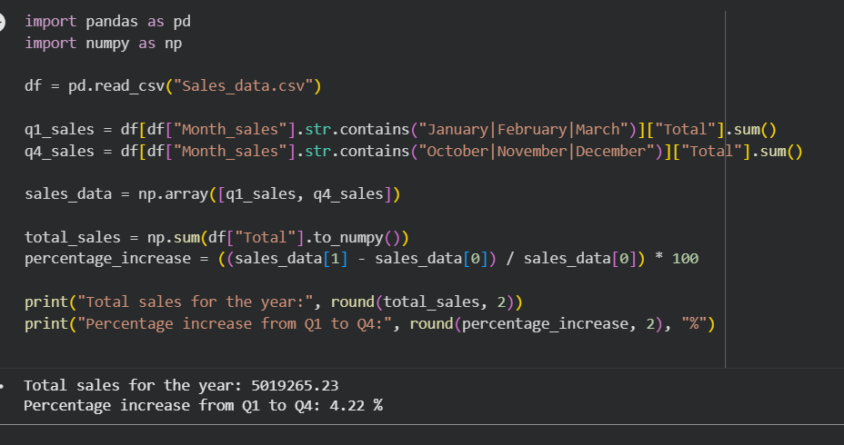

Experiment 5
Program:
import pandas as pd
import numpy as np
df = pd.read_csv("auto-mpg.csv", encoding="latin1")
df.columns = df.columns.str.strip()
df = df.dropna(subset=["mpg"])
fuel_efficiency = df["mpg"].values
average_efficiency = np.mean(fuel_efficiency)
percentage_improvement = (
(fuel_efficiency[-1] - fuel_efficiency[0]) / fuel_efficiency[0]
) * 100
print("Average Fuel Efficiency:", round(average_efficiency, 2), "mpg")
print("Percentage Improvement in Fuel Efficiency:", round(percentage_improvement, 2), "%")

Output:
